MASTERS OF MASS TORT: MASS TORT SPEED SESSION
NAME OF LITIGATION: PFAS Water Contamination Litigation
BRIEF SUMMARY
PFAS contamination cases in both municipal and residential well water supplies are emerging in various states and communities and have become a significant environmental crisis. PFAS has historically not been regulated, and advisory levels vary from state to state. The resulting natural resource damage, damage to private property interests and human health are the basis for the claims filed in various class actions and individual and consolidated lawsuits. The primary defendants involved include 3M, Saint Gobain, Honeywell, Dupont and Worldwide Wolverine.
THE BIG PICTURE
The claims against, and damages sought from defendants include negligence, public and private nuisance, diminution in property value, loss of use and enjoyment of property; loss of quality of life, personal injuries and illness, abatement and remediation, medical monitoring, and other economic harms. The nature of the claims is determined by the role the defendant played in bringing about the damages. e.g. 3M in Minnesota for disposal, while in Michigan products liability claims, and the laws of the state in which they are brought. e.g. Michigan doesn’t recognize medical monitoring.
THE NUMBERS
The discovery of PFAS contamination of public and private water supplies is rapidly growing in municipalities and states. As a result, the litigation is proliferating as described below:
- CURRENT LITIGATION/MDL STATUS
  - Landscape of Non AFFF National Litigation
    - Michigan:
      - Kent County Cases vs. Worldwide Wolverine
        - Moen v. Worldwide Wolverine (consolidated individual cases)
        - Johns v. WWW et al (class cases removed to WD MI Fed Ct.)
        - Nyland Consolidated individual cases
        - Zimmerman (WD MI cases)
      - Parchment, MI

- New York
  - Hoosick Falls
Baker, et al. v. Saint-Gobain Performance Plastics, Case No. 16-917, N.D. NY class action and individual cases; Master Consolidated Complaint vs Saint-Gobain Performance Plastics Corp. and Honeywell International Inc. f/k/a Allied-Signal Inc. and/or AlliedSignal Laminate Systems, Inc. E.I. DuPont De Nemours, and 3M Co.
- Petersburgh: Burdick v. Tonoga, No. 253835, Rensselaer Cnty., NY Supreme Ct. Class action and Individual cases;
Classes certified for:Town Water Property Damage Class; Private Well Property Damage Class, private Well Nuisance Class, PFOA Invasion Injury Class
- Vermont:
  - AG Case: State filed suit against Saint-Gobain. In July 2017, Saint-Gobain entered into a consent agreement to provide $20 million to extend municipal water lines to about 200 homes in the Bennington area.
  - Sullivan, et al. v. Saint-Gobain Performance Plastics Corp., 16-125, D.VT. - class action seeking compensation for property damage and medical monitoring.
- New Hampshire
  - Brown et al. v. Saint-Gobain Performance Plastics, 16-242, D.NH. Consolidated class actions
- Minnesota
  - City of Lake Elmo v. 3M Company, 16-02557, D. MN.
Municipality suing 3M for PFAS disposal under CERCLA based on PFAS within “catch-all” definition of hazardous waste under the Solid Waste Disposal Act; also claims for trespass; negligence; conversion.
- Alabama
  - West Morgan-East Lawrence Water and Sewer Authority, et al. v. 3M Company, et al., 15-cv-1750 (N.D. Ala.) Consolidated class and individual water authority action. Claims include negligence, public nuisance, abatement of nuisance, battery.
  - Decatur, Alabama: Tennessee Riverkeeper, Inc. v. 3M Company, et al., 16-01029 (N.D. Ala.) RCRA suit against 3M for PFAS disposal seeks remediation. Discovery pending; bench trial ordered.
- AFFF MDL
In December 2018, the JPML consolidated approximately 75 lawsuits filed by individuals, municipalities, and water authorities alleging PFOA/PFOS contamination by aqueous film-forming foams (AFFFs), transferring them to Judge Gergel of the District of South Carolina.
Two State AG cases State of New York v. 3M Company et al., No. 1:18-cv-01317 (N.D.N.Y) and State of Ohio v. 3M Co., et al., No. 3:19-cv-00120 (N.D. OH)) also transferred, have opposed transfer. Oral argument is set for March 28, 2019.

- Settlements
  - In 2004, as part of a class action settlement in West Virginia/Ohio Valley cases, DuPont agreed to develop, fund and implement the C-8 Panel/C-8 Study. Per the terms of the settlement, if the C-8 Panel found probable links between certain conditions and PFOA, class members with those conditions could file individual lawsuits against DuPont.
  - The C-8 Panel’s findings resulted in the filing of approximately 3,500 individual personal injury lawsuits against DuPont and its spinoff, Chemours which settled for $671M in In February 2017.
  - In February 2018, 3M settled a groundwater pollution lawsuit with the State of Minnesota for $850 million.

RULINGS OF NOTE
- Medical Monitoring:
  - Hoosick Fall, NY: decision in favor of plaintiffs; Defendants appealed to 2d Cir in Baker, et al. v. Saint-Gobain Performance Plastics, Case No. 17-3942, 2d Cir. Fully briefed and awaiting oral argument in April 2019;
  - New Hampshire:
- Class Certification:
  - Petersburgh
GENERAL PFAS INFORMATION AND STATUS OF REGULATORY INVOLVEMENT
PFAS Generally
PFOA and PFOS are part of a class of man-made chemicals that are not naturally occuring in the environment. As a result of decades of lobbying by industries that manufactured PFAS containing products they have been unregulated, leading to decades of unregulated use and disposal of these highly hazardous substances.
Due to their chemical structure, PFOA and PFOS are biologically and chemically stable in the environment and resistant to environmental degradation and thus remain present in the environment long after they are initially discharged causing serious environmental damage and risks to human health.
PFAS chemicals bio-accumulate in living organisms, primarily in the blood serum, kidney and liver and remain in the human body. PFAS exposure is associated with increased risk in humans of testicular cancer, kidney cancer, prostate cancer, pancreatic cancer, ovarian cancer, non-Hodgkin’s lymphoma, thyroid disease, high cholesterol, high uric acid levels, elevated liver enzymes, ulcerative colitis and pregnancy-induced hypertension, among other health issues.

Regulatory Activity
The EPA recently announced its intent to regulate these chemicals by (1) proposing a federal MCL for PFOA and PFOS by the end of 2019 (2) develop nationwide drinking water monitoring for PFAS (3) develop interim cleanup recommendations to address PFOA/PFOS-contaminated groundwater. Currently there are only advisory levels and they vary from state to state.

ATSDR Tox Profile
In June 2018, the ATSDR issued a draft Toxicological Profile for Perfluoroalkyls which recommended reducing the draft Minimal Risk Level (MRL) for PFOA and PFOS.
Notably, the ATSDR Tox Profile indicates potential health impacts at lower concentrations than the existing EPA 70 ppt Health Advisory.

ATSDR Biomonitoring Study
The ATSDR is designing and developing a multi-site PFAS health study to study the relationship between PFAS and human health outcomes in multiple communities with PFAS contaminated drinking water. The multi-site PFAS health study’s design will be informed by agency and state health partners currently investigating exposure to and possible health effects associated with PFAS in more than 30 communities across the US, including Alabama, Alaska, California, Colorado, Massachusetts, Michigan, New Hampshire, New York, Pennsylvania, and Washington.

State PFAS Drinking Water Guidelines and Regulations
The following states have enacted regulations or non-enforceable regulatory guidelines that differ from the 70ppt EPA Health Advisory.

State | Drinking Water Action | Compound | Level (ppt)
CA | Interim Response Levels  Interim Notification Levels | Sum of PFOA and PFOS  PFOS  PFOA | 70  13  14
CT | Action Level | Sum of PFOA, PFOS, PFNA, PFHxS, PFHpA | 70
ME | Maximum Exposure Guideline | Sum of PFOA and PFOS | 70
MASS | Office of Research & Standards Guideline | Sum of PFOA, PFOS, PFNA PFHxS, PFHpA | 70
MN | Health Based Value Guidance | PFOA  PFOS | 35  27
NH | Proposed Regulations | PFOA  PFOS  Sum of PFOA and PFOS  PFHxS  PFNA | 38  70  70  85  23
NJ | MCL  Proposed MCL | PFNA  PFOA  PFOS | 13  14  13
VT | Enforcement Standard | Sum of PFOA, PFOS, PFNA, PFHxS, and PFHpA | 20

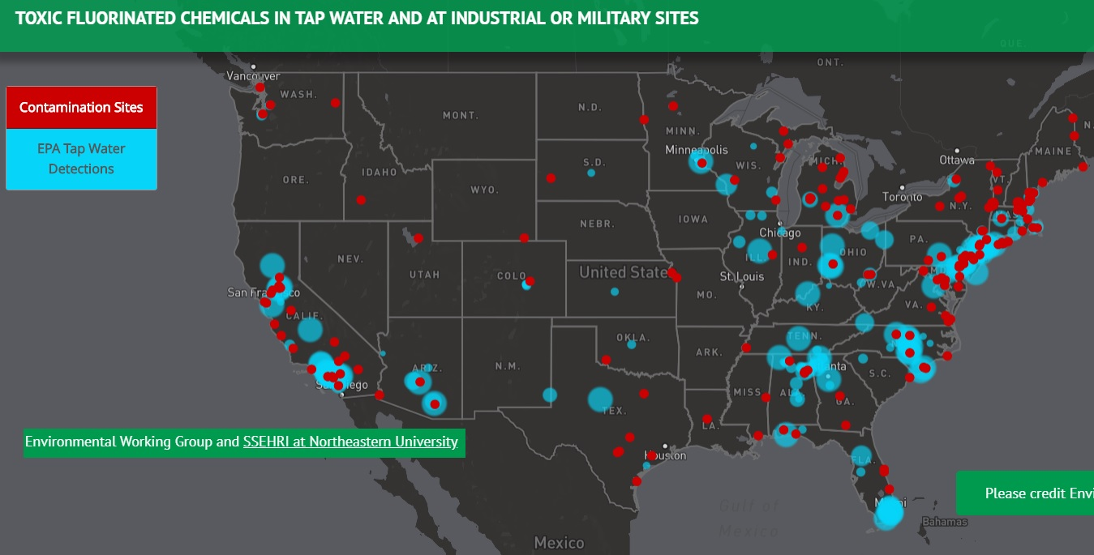

This level, proposed by the CA Division of Drinking Water, would require removing a water source from service if the concentration level cannot be reduced below the 70 ppt Response Level.
This level, proposed by the CA Division of Drinking Water, would require removing a water source from service or adding proper treatment when the concentration exceeds the Notification Levels of 13 ppt (PFOS) and/or 14 ppt (PFOA).
In rulemaking process now, final proposals expected to be filed Summer 2019.

